Pokemon GO – Analysis of My Perfect Pokemon

# What is Pokemon?

Pokemon is a franchise, created by Satoshi Tajiri the chairman of Game Freak. As a child, he was interested in collecting and studying bugs that were in the forests of Japan. In his early life, he was referred to as “Dr. Bug,” and an enjoyer of video games. Originally, he wanted to become an entomologist – a bug studier. However, due to his low grades and delinquency, he would end up getting his high school diploma later than anticipated. Instead, he pursued his love for video games and came up with the idea of creating a game where you collect different creatures that are similar to real-life animals and objects. The player would collect these creatures inside an object that resembles a capsule-like ball. Said player would also be able to form bonds and friendships with these creatures, as well as battle other creatures. This game would be called Pokemon or Pocket Monsters.

Pokemon was initially released on February 27, 1996, in the form of two versions for the Gameboy: Pocket Monsters Red and Pocket Monsters Green. In the original games, you play as a young boy named “Red,” but you can change his name. The professor named Oak, wants you to collect all 151 Pocket Monsters, as well as battling trainers to become the Champion of the Kanto Region. There are eight gyms in Kanto, where eight stronger than usual trainers await the player to challenge them and win. Battling and winning against these gyms will earn the player a badge of sorts. By collecting all eight gym badges, the player can challenge a special facility that houses four trainers known as The Elite Four. After defeating The Elite Four, the player fights the strongest trainer in the games known as the champion. While this story is going on, there is an evil gang of trainers known as Team Rocket. They are a group of trainers who illegally sell, steal, and traffic Pokemon, to make profits and help their leader, Giovanni, take over the Kanto Region. The player is successful at stopping his plans. Not only that, but with 151 Pokemon to collect, this game was packed with content for a small Gameboy cartridge.

Initially, the games received mixed reviews, since the games had a number of glitches, as well as some of the Pokemon looking rather odd or… uncanny. However, since millions of copies were sold in Japan, the game would be released outside of Japan, renamed to “Pokemon,” as a shorter version of the Japanese title. In 1998, Pokemon Red and Pokemon Blue would be released outside of Japan. The series would become a juggernaut in pop culture, with nine different generations that have been released, with the most recent generation of games being Pokemon Scarlet and Pokemon Violet for the Nintendo Switch. As of this study, there have been a total of 1,025 different Pokemon to collect!

Later installments of Pokemon have changed up the usual formula to the main story. In Pokemon Sun and Moon, there aren’t any gym leaders to challenge. Instead, the player must complete island challenges that are all across the Alola Region. After completing these challenges, the player fights a very strong and powered up Pokemon known as a “Totem Pokemon.” After defeating this Totem Pokemon, the player will eventually fight the leader of the island known as the Island Kahuna. After fighting the Island Kahunas, the player will eventually make their way to The Elite Four and champion. Another installment that changed the formula was Pokemon Legends: Arceus. In this game, the player is sent back to an ancient version of the Sinnoh Region known as the Hisui Region. Back then, the devices for catching Pokemon, Poke Balls, were made with fruits called Apricorns. Pokemon were also feared, with some being able to attack and even incapacitate the player. The player was sent back in time, to figure out why there have been anomalies in the space-time continuum, as well as seeking out the Pokemon of ancient Hisui. Lastly, one of the installments that would make a big change to the formula would be the topic of my research: Pokemon GO.

# What is Pokemon GO?

Pokemon GO is a mobile game that was released in July 2016 as a joint effort between Nintendo, Game Freak, and Niantic Inc. The game uses the phone’s GPS (Global Positioning System) system, to help track Pokemon within the real-world. The game has similar elements to the main Pokemon franchise’s games, with the ability to catch and collect Pokemon by using Poke Balls, as well as train them. While gyms exist in Pokemon GO, they don’t function the same way in the mainline games. Gyms offer badges, but since there are thousands of them, there isn’t an Elite Four or champion of any kind. Instead, the real goal of the game is to just explore different locations and areas of the world. In the game, you can join one of three teams, where thankfully, they’re not affiliated with any gangs or evil organizations. In the mainline and spin-off games, teams are often associated with evil goals and sabotaging the player’s goals to become the champion:

* Team Rocket (Giovanni): Illegally obtaining and selling Pokemon
* Team Aqua (Archie): Awakening an ancient Pokemon that is known to cause monsoons, to expand the sea
* Team Magma (Maxie): Awakening an ancient Pokemon that is known to cause droughts, to expand the land mass
* Team Galactica (Cyrus): Try and control Pokemon who have created Time and Space, in order to remake the universe
* Team Plasma (Ghetsis): Adopt a child, use their ability to communicate with Pokemon, to make it so that people will ditch and release their Pokemon, in order for the boss to be the one to control all Pokemon
* Team Flare (Lysandre): Restore the ultimate weapon used by AZ, in order to destroy all of humanity and preserve the beauty that exists within Pokemon and the natural world
* Team Skull (Guzma): Delinquents who just want to cause trouble for other people
* Aether Paradise (Lusamine): Wants to find her husband Mohn, after being taken away by Pokemon known as Ultra Beasts. She becomes insane and neglectful of her own children by trying to locate his whereabouts.
* Team Yell (Piers): Delinquent fans of Marnie and Piers, who cause trouble for other people.
* Macro Cosmos (Rose): Wants to awaken an ancient Pokemon, to solve an energy crisis that won’t happen for another 1,000 years.
* Team Star (Penny): Students of the Naranja/Uva Academy who were bullied by other students and formed a group of delinquents and bullies themselves.
* Professor Sada/Professor Turo: Fascinated about either the past or future (depending on which version is played). Their fascination would end up neglecting their family and ending up with forming a powerful AI that tried to preserve the Pokemon that they found.
* Miss Fortunes (Charm, Coin and Clover): Delinquents and bandits that want to cause trouble for the Diamond Clan, Pearl Clan, and others.
* Ginkgo Guild (Volo): While he’s not the leader of the guild, he is the most prominent figure of this group. He ends up betraying the player, to try and befriend Arceus, to exploit its powers.

In spinoff titles (Games I’ve played):

* Team Meanies (Gengar, Medicham, Ekans): Sabotage the player’s journey and spread rumors about the player’s transformation into a Pokemon bringing a mass calamity.
* Team Skull (Skuntank, Koffing, Zubat): Sabotage and bully the player and their friend, while being part of the Wigglytuff Guild.
* Team Phobos/Phobos Battalion (Baron Phobos): Steal Pokemon from trainers, to use their energy, to power up a secret weapon called the Phobosphere.
* Team Cipher (Evice and Master Greevil): Create an evil version of Pokemon, known as Shadow Pokemon. They have no emotions, no control over their powers, and are used for nefarious deeds.
* Team Snag’em (Gonzap): The lackeys to Team Cipher, to steal Pokemon from trainers, to be made into Shadow Pokemon.
* Team Go-Rock Squad (Gordor): Wants revenge for being upstaged by Prof. Hastings by building a Power Styler that can control any Pokemon.

However, in Pokemon GO’s case, the leaders of the three main teams are not evil:

* Team Mystic (Blanche): Calm, collected, and analytical, Blanche’s team is represented by Articuno.
* Team Instinct (Spark): Naïve, energetic, and intuitive, Spark’s team is represented by Zapdos.
* Team Valor (Candela): Passionate, strong, and explorative, Candela’s team is represented by Moltres.

You can join either one of these three teams, as they are all assistants of Professor Willow and friends of GO Ultra Recon Squad member Rhi. However, an evil team does exist in Pokemon GO. Team Rocket makes a return in this game, in the form of Team GO Rocket, with their plans to sabotage the player’s adventure by appearing at Pokestops and following the player inside a hot air balloon. Giovanni resumes the role as the leader of Team GO Rocket, and has three admins that are willing to rival the team leaders:

* Team Mystic’s main rival (Admin Cliff): Loyal and strong, but quick tempered, Cliff is considered to be Blanche’s main rival.
* Team Instinct’s main rival (Admin Sierra): Flirtatious, but with a knowledge of how to fight, Sierra is considered to be Spark’s main rival.
* Team Valor’s main rival (Admin Arlo): Stoic and egotistical, Arlo is considered to be Candela’s main rival.

Team GO Rocket uses Shadow Pokemon, which were first introduced in Pokemon Colosseum and XD: Gale of Darkness. In these games, Team Cipher made Shadow Pokemon, which are a type of Pokemon that have lost their emotions and were artificially made into fighting machines. In Pokemon GO, you can find these Shadow Pokemon at Pokestops that are a darker color. You can also use a Rocket Radar, to obtain Shadow Pokemon from Team GO Rocket’s admins, as well as the Super Radar to find Giovanni himself. Also, occasionally, there is a hot air balloon that will appear every six hours. One of Team GO Rocket’s members will fight you. Thankfully, we can decipher what their lackeys can use:

Male Grunts:

* “Normal does not mean weak.” (Normal-Types)
* “Go, my super bug Pokemon!” (Bug-Types)
* “Are you afraid of psychics that use unseen power?” (Psychic-Type)
* “Don’t tangle with us!” (Grass-Types)
* “You’re no match for my iron will!” (Steel-Types)
* “Let’s rock and roll!” (Rock-Types)
* “You’ll be defeated into the ground!” (Ground-Types)
* “Ke… Ke… Ke… Ke… Ke... Ke!” (Ghost-Types)
* “These waters are treacherous!” (Magikarp and rarely Gyarados, Water-Types)
* “Winning is for winners.” / “Get ready to be defeated!” / “Don’t bother – I’ve already won.” (Starter Pokemon / Grass, Fire, and Water-Types)

Female Grunts:

* “These waters are treacherous!” (Water-Types)
* “This buff physique is not for show!” (Fighting-Types)
* “ROAR! …How did that sound?” (Dragon-Types)
* “Get ready to be shocked!” (Electric-Types)
* “Do you know how hot Pokemon fire breath can get?” (Fire-Types)
* “Battle against my Flying-Type Pokemon!” (No fun… Flying-Types)
* “Coiled and Ready to strike!” (Poison-Types)
* “Check out my cute Pokemon! (Fairy-Types)
* “You’re gonna be frozen in your tracks.” (Ice-Types)
* “Wherever there is light, there is also shadow.” (Dark-Types)
* “Winning is for winners.” / “Get ready to be defeated!” / “Don’t bother – I’ve already won.” (A mess of Snorlax, Poliwrath, Gardevoir, Gyarados, and Dragonite)

After defeating one of the grunts, you have the opportunity to catch a Shadow Pokemon and to receive a part of the Rocket Radar, if you don’t have one already. Shadow Pokemon can be purified, which will add two IVs to each of its stats, so this is a very common method of obtaining Perfects. However, some people keep these Pokemon as a Shadow Pokemon, because of their increased damage outputs. Shadow Pokemon can only have two moves: a fast move, and Frustration. These Pokemon cannot have their moves changed, unless if there is a specific GO Rocket themed event that changes up the grunts’, admins’, and Giovanni’s teams around.

# Pokemon GO Locations

With this in mind, Pokemon GO has locations that represent real-world locations, in the form of gyms and Pokestops. Pokestops are locations that give players items and a task to do. These places can be in just about any part of the world, but with a few exceptions.

* Pokestops aren’t located in areas that don’t have Pokemon GO support. Countries like Burundi, Guinea-Bissau, Eswatini, Micronesia, Marshall Islands, Nauru, Somalia, and Tuvalu don’t have Pokestops.
* While there are Pokestops in China, Russia, Belarus, and North Korea, the game is not downloadable in these countries.
* Pokestops are harder to find in rural and remote areas.

Gyms are places where other players can deposit their Pokemon, to defend their team’s honor and name. Gyms can also give items to players, but they don’t give any tasks for a player to do. They are color coded, to represent the team that is in control of the gym (red = Team Valor, blue = Team Mystic, yellow = Team Instinct). A gym can hold up to six Pokemon at a time. If a Pokemon is knocked out, that Pokemon will return to the player that deposited it. Said player will receive an in-game currency called “Pokecoins,” which can buy items for catching, training, and finding Pokemon. At gyms, occasionally, a cocoon of some kind will appear. This contains a very powerful Pokemon that may require more than one trainer to defeat. These cocoons will reveal the hidden Pokemon after a certain amount of time, usually about an hour. The cocoons can be different colors, with some having either a shadow aura, indicating a Shadow Pokemon, or they can have a strange pattern indicating a Mega-Evolved Pokemon, or is part of an event. Raid passes are required to join a raid, which can be bought with Pokecoins. The player can also receive one raid pass (orange), every day. The cocoons that can appear are:

* Light-Pink: One-star Raids. These raids are very easy to play by yourself.
* Yellow: Three-star Raids. These raids can be beaten on your own, but it’s wise to invite others to these raids.
* Gray: Five-star Raids. These raids often contain legendary or mythical Pokemon, which are very strong and rarer Pokemon to find. Definitely do these with at least 5 or more people who play Pokemon Go.
* Magenta: Elite Raids. These raids contain a rarer legendary Pokemon, which don’t appear that often. Elite Raids can only be done in-person.
* Shadowy Aura: Indicates a Shadow Pokemon. When doing these raids, the Pokemon can become enraged, where their attacks are stronger, and your attacks are weaker. Use purification gems to calm them down, which you can find by defeating GO Rocket grunts. These raids can only be done in-person.
* Mega-Evolution Symbol: Indicates a Mega-Evolved Pokemon as the boss. Mega Evolution was introduced in generation six, as a way to make some Pokemon stronger.
* Red Crystal: For some events, a strong version of Groudon can appear at raids with a reddish crystal that has the omega symbol. This version of Groudon is called “Primal Groudon.”
* Blue Crystal: For some events, a strong version of Kyogre can appear at raids with a bluish crystal that has the alpha symbol. This version of Kyogre is called “Primal Kyogre.”

Gyms also looked different back then, when the game was first released. For a while, they looked more tower-like and angular, where you had to constantly fight (or train) against gyms that were the same color as your team to allow for more Pokemon to be stored there.

After roughly a year after Pokemon GO’s release, gyms were updated, so that up to 6 Pokemon could be deposited at a gym. If the gym is associated with the same team as yours, you can either deposit Pokemon (excluding Legendaries and Mythicals) if there is enough room, or use berries to restore a Pokemon’s health (up to 10 times per Pokemon). When the Pokemon’s health is gone (based on their Combat Power or CP), then that Pokemon will return to their trainer and said trainer will get a set amount of PokeCoins, depending on how long that Pokemon was stored there at the gym. Up to 50 PokeCoins can be obtained from gyms each day. Extra PokeCoins can be purchased with money through the app store.

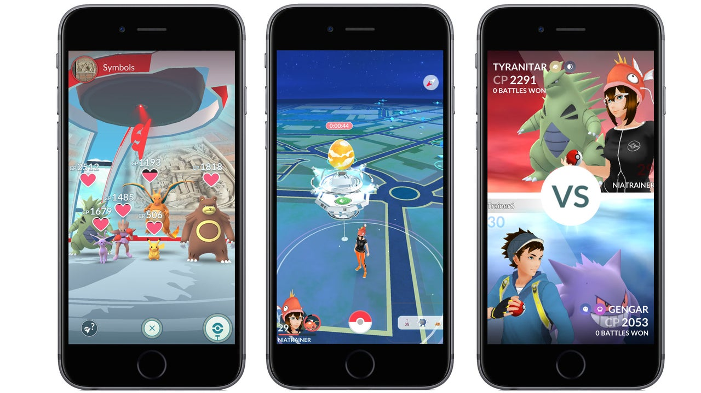

Since the update in early September of 2024, a new form of gym was introduced called Dynamax Gyms. Dynamax and Gigantamax are gimmicks that came from the 8th Generation of Pokemon (i.e., Sword and Shield). Both gimmicks involve making the Pokemon larger, which in turn, will make them more powerful. Only certain Pokemon can Gigantamax, but most Pokemon can Dynamax, though these Pokemon will be slowly released in Pokemon GO. In Pokemon GO, you need something called Max Particles to join a Dynamax Raid. You can only collect up to 800 Max Particles per day, but each Dynamax raid lasts for a couple of days. Though, you can only Dynamax during daylight hours (so, from 6am – 9pm). When joining, only Dynamax and Gigantamax Pokemon can join these raids, as you will be utilizing this power after whittling down the foe’s HP. There is a time limit of having a certain amount of Pokemon being knocked out. If that amount of Pokemon are knocked out, then you’ll have to start the whole fight over. Dynamax Raids are more common, whereas Gigantamax Raids are rarer to find as they’re usually found during events. Catching one of these Pokemon will make your Poke Balls and Premier Balls larger.

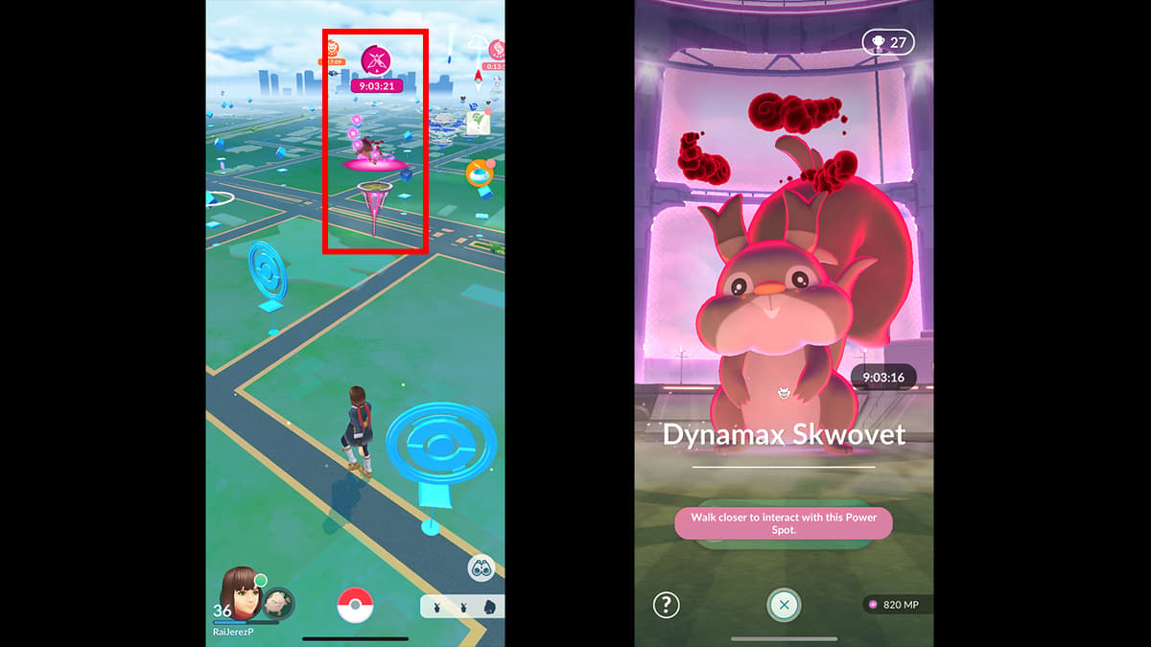

After catching them, you can level up their moves and learn moves to help heal your Pokemon, as well as help them endure attacks. These also cost Max Particles. Plus, Dynamax and Gigantamax Pokemon that you’ve caught will have the Dynamax or Gigantamax mark, next to their icon.

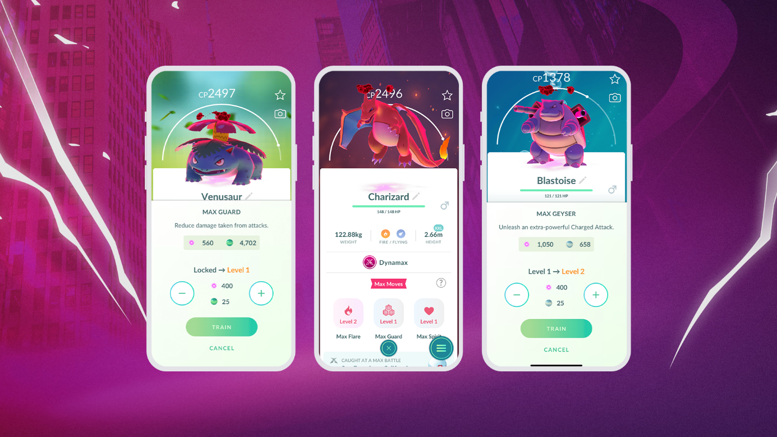

Since Pokemon GO also uses real-world tracking, it can also track a person’s steps and how long they’ve walked. There are certain rewards for walking certain distances. From Pokestops, gifts from friends, and Gyms, you can receive eggs that will eventually hatch into a Pokemon. These eggs come in different colors, and have require different amounts of distances to hatch them. Here are the different kinds of eggs one can find:

* Green: Takes 2km to hatch
* Orange: Takes 5km to hatch
* Blue: Takes 10km to hatch
* Yellow with Pink spots: From gifts, takes 7km to hatch
* Red: From defeating GO Rocket Admins, takes 12km to hatch

The player is given an incubator that can be used an infinite number of times. The player can also buy incubators from the shop, for some Pokecoins. The super incubator can make egg hatching faster. Plus, some events will make hatching eggs faster. The game uses kilometers, to measure distance.

Trading with friends is another way to obtain Pokemon. In order to friend someone, you’ll need to find their friend code, and register them as a friend within your account. Pokemon can be traded between people, if they are up to 100 meters near you. Pokemon that are traded cannot be re-traded to other people. Certain Pokemon like mythicals (Mew, Celebi, Jirachi, etc.) cannot be traded between other players. You’ll also be spending a currency called stardust when trading between friends. Stardust is collected by catching Pokemon, opening gifts, hatching eggs, feeding berries to Pokemon at gyms, completing tasks, and defeating GO Rocket members. Trading can help evolve some Pokemon, like Hauter and Golem. Some Pokemon don’t appear in certain locations, so they will most likely be obtained through trades. These Pokemon are:

* Farfetch’d (Only in South Korea, Taiwan, Japan, and Hong Kong)
* Kangaskhan (Only in Australia)
* Mr. Mime (Only in Europe)
* Tauros (Only in The United States and Southern Canada)
* Heracross (Central and Southern America)
* Corsola (Between 31N and 26S latitudes on the coasts)
* Volbeat (Europe, Asia, and Australia)
* Illumise (North America, South America, and Africa)
* Torkoal (Western and Southeastern Asia)
* Zangoose (Europe, Asia, and Australia)
* Seviper (North America, South America, and Africa)
* Lunatone (Western Hemisphere)
* Solrock (Eastern Hemisphere)
* Tropius (Africa and the Middle East)
* Relicanth (New Zealand and Oceania)
* Pachirisu (Parts of Canada, Alaska, and Russia)
* Chatot (Southern Hemisphere)
* Carnivine (Southeastern United States)
* Shellos (West Sea – Western Hemisphere; East Sea – Eastern Hemisphere)
* Mime Jr. (Europe from 5km eggs)
* Uxie (Asia-Pasific)
* Mesprit (Europe, Middle East, Asia, and Africa)
* Azelf (North America, South America, and Greenland-Denmark)
* Pansage (Asia-Pacific)
* Pansear (Europe, Middle East, Africa, and India)
* Panpour (North America, South America, and Greenland-Denmark)
* Sawk (Europe, Asia, and Australia)
* Throh (North America, South America, and Africa)
* Basculin (Red-Striped – Eastern Hemisphere; Blue-Striped – Western Hemisphere)
* Maractus (Mexico, Central America, and South America)
* Sigilyph (Egypt and Greece)
* Bouffalant (New York)
* Heatmor (Europe, Asia, and Australia)
* Durant (North America, South America, and Africa)
* Klefki (France, Luxembourg, UK’s Southeastern Coast, and Western Switzerland)
* Oricorio (Baile Form – Europe, Middle East, and Africa; Pom-Pom Form – The Americas; Pa’u Form – African, Asian, Oceania, and Caribbean Islands; Sensu Form – Asia-Pacific)
* Furfrou (Debutante Trim – Americas; Diamond Trim – Europe, Middle East and Africa excluding Egypt; Star Trim – Asia-Pacific; La Reine Trim – France; Kabuki Trim – Japan; Pharaoh Trim – Egypt; Heart Trim – Only on Valentine’s Day)
* Comfey (Hawaii)
* Flabebe (Red Flower – Europe, Middle East, and Africa; Yellow Flower – The Americas; Blue Flower – Asia-Pacific)
* Hawlucha (Mexico)
* Celesteela (Southern Hemisphere)
* Kartana (Northern Hemisphere)
* Vivillon (Patterns are obtained from pinning postcards from friend’s gifts)

Sometimes, these Pokemon can appear in other countries during events. However, most of these Pokemon have to be either obtained through a trade, or the player will have to go to the specific location themselves, which can be expensive. Therefore, trading with other players is the more desirable option. If you’re friends with a person for a long time in the game, a Lucky Trade can be made. These kinds of trades are guaranteed to result with receiving a Pokemon that will have at least three stars, or is very strong. Trading a Pokemon that a person doesn’t have will result in using more stardust, so being friends for a long time with other players is an excellent way to obtain Lucky Trades, as well as lowering the required amount of stardust for trading Pokemon.

# Tasks and Pokemon

Wild Pokemon can appear within the game. By catching said Pokemon, you can power it up, or transfer it to Professor Willow. In these games, each Pokemon has a type. Not only that, but each Pokemon can know a total of up to three moves, in the game. In total, there are 18 types for each move and Pokemon:

* Normal (very basic Pokemon typing. Weak to Fighting-Types, and not affected by Ghost-Types. Not strong against any types, doing no damage to Ghost-Types, and barely does damage to Rock and Steel-Types.)
* Fire (controls fire of some kind. Strong against Grass, Ice, Bug, and Steel-Types, weak against Water, Ground, and Rock-Types, resists Fire, Grass, Ice, Steel, and Fairy-Types, and doesn’t do much damage to Fire, Water, Rock, and Dragon-Types.)
* Water (controls water. Strong against Fire, Ground, and Rock-Types, weak to Electric and Grass-Types, resists Water, Fire, Ice, and Steel-Types, and doesn’t do much damage to Water, Grass, and Dragon-Types.)
* Grass (controls plants and grass. Strong against Water, Ground, and Rock-Types, weak to Fire, Ice, Poison, Flying, and Bug-Types, resists Water, Grass, Electric, and Ground-Types, and doesn’t do much damage against Fire, Grass, Poison, Flying, Bug, Dragon, and Steel-Types.)
* Electric (controls electricity and electrical currents. Strong against Water and Flying-Types, Weak to Ground-Types, resists Electric, Flying, and Steel-Types, doesn’t do much damage to Grass, Electric, and Dragon-Types, and cannot harm Ground-Types.)
* Ice (controls ice and cold elements. Strong against Grass, Ground, Flying, and Dragon-Types, weak to Fire, Fighting, Rock, and Steel-Types, resistant to Ice-Types, and doesn’t do much damage to Fire, Water, Ice, and Steel-Types.)
* Fighting (master of martial arts, fighting, and using their body to fight. Strong against Normal, Ice, Rock, Dark, and Steel-Types, weak to Flying, Psychic, and Fairy-Types, resists Bug, Rock, and Dark-Types, doesn’t do much damage to Poison, Flying, Psychic, and Fairy-Types, and doesn’t do damage to Ghost-Types.)
* Poison (masters of using poisons and toxins. Strong against Grass and Fairy-Types, weak to Ground and Psychic-Types, resists Grass, Fighting, Poison, Bug, and Fairy-Types, doesn’t do much damage to Poison, Ground, Rock, and Ghost-Types, and doesn’t do damage to Steel-Types.)
* Ground (controls earth, soil, and sand. Strong against Fire, Electric, Rock, and Steel-Types, weak to Water, Grass, and Ice-Types, immune to Electric-Types, resistant to Poison and Rock-Types, doesn’t do much damage to Grass and Bug-Types, and does no damage to Flying-Types.)
* Flying (controls air currents, can fly, and/or forces of wind. Strong against Grass, Flying, and Bug-Types, weak to Electric, Rock, and Ice-Types, immune to Ground-Types, resists Grass, Fighting, and Bug-Types, and doesn’t do much damage to Electric, Rock, and Steel-Types.)
* Psychic (masters of the mind and psychic abilities. Strong against Fighting and Poison-Types, weak to Ghost and Dark-Types, resistant to Psychic and Fighting-Types, doesn’t do much damage to Psychic and Steel-Types, and doesn’t do damage to Dark-Types.)
* Bug (utilizes powers of bugs. Strong against Grass, Psychic, and Dark-Types, weak to Fire, Rock, and Flying-Types, resistant to Grass, Fighting, and Ground-Types, and doesn’t do much damage to Fire, Fighting, Poison, Ghost, Steel, and Fairy-Types.)
* Rock (utilizes rocks, boulders, mountains, and parts of the Earth. Strong against Fire, Ice, Flying, and Bug-Types, weak to Water, Grass, Ground, Fighting, and Steel-Types, resists Normal, Fire, Poison, and Flying-Types, and doesn’t do much damage to Fighting, Ground, and Steel-Types.)
* Ghost (utilizes paranormal and spiritual powers. Strong against Ghost and Psychic-Types, weak to Dark and Ghost-Types, resists Poison and Bug-Types, doesn’t do much damage to Dark-types, and doesn’t do damage and is immune to Normal-Types.)
* Dragon (mythical or mirages, based on cold-blooded animals. Strong against Dragon-Types, weak to Ice, Dragon, and Fairy-Types, resists Fire, Water, Grass and Electric Types, doesn’t do much damage to Steel-Types, and cannot affect Fairy-Types.)
* Dark (utilizes shadows, darkness, cruelty, or malice. Strong against Ghost-Types and Psychic-Types, weak to Fighting, Bug, and Fairy-Types, resists Ghost and Dark-Types, and doesn’t do much damage to Dark and Fairy-Types.)
* Steel (utilizes metal, magnetism, and sharp objects. Strong against Ice, Rock, and Fairy-Types, weak to Fire, Fighting, and Ground-Types, immune to Poison-Types, resists Normal, Grass, Ice, Flying, Psychic, Bug, Rock, Dragon, Steel, and Fairy-Types, and doesn’t do much damage to Fire, Water, Electric, and Steel-Types.)
* Fairy (utilizes mystical and natural powers. Strong against Fighting, Dragon, and Dark-Types, immune to Dragon-Types, resistant to Fighting, Bug, and Dark-Types, weak to Steel and Poison-Types, and doesn’t do much damage to Fire, Poison, and Steel-Types.)

Some Pokemon can have a combination of two typings, which can either increase or decrease the amount of damage they receive from an attacker. If a Pokemon uses an attack that is the same type as it, it will do an extra amount of damage. Sometimes, in the game, attacks can be boosted by the weather. Since the game uses GPS and real-time locations, weather patterns can affect the game. Here’s a list of the weather and which types are effected:

* Sunny: Grass, Fire, and Ground-Types are boosted
* Partly Cloudy: Normal and Rock-Types are boosted
* Cloudy: Poison, Fighting, and Fairy-Types are boosted
* Rainy: Water, Electric, and Bug-Types are boosted
* Foggy: Dark and Ghost-Types are boosted
* Snowy: Steel and Ice-Types are boosted
* Windy: Dragon, Flying, and Psychic-Types are boosted

Some tasks can reward a Pokemon, which can vary depending on updates inside the game. Sometimes, tasks can be based around events that are released within the game. These events are usually announced, so players have enough time to prepare for these future events. For example, on “community days,” a specific species of Pokemon will appear from 2pm – 5pm and have tasks catered towards catching said species of Pokemon. For these rewards, the player can encounter stronger versions of Pokemon that have higher values called “individual values,” or IVs. In Pokemon GO, IVs can range from 0 to 15, in Attack, Defense, and HP. If a Pokemon has 15 IVs in all of these stats, they are referred to as either “perfects,” or “4*s,” or “hundos.” Even rarer are shiny variants called “shundos.”

Shiny Pokemon were introduced in Pokemon Gold and Pokemon Silver, as these games were released for the Gameboy Color. Shiny Pokemon are variations of regular Pokemon that have a different color. Encountering a Pokemon that is Shiny will have a sparkling effect, often catching the player off-guard. Plus, the Pokemon will have a different color. For example, Pikachu, the most popular Pokemon usually appears yellow with red cheeks. However, if someone finds a shiny, it will be orange, with pink cheeks. Back then, Shiny Pokemon had appeared 1 in every 8,192 regular Pokemon, but that number was reduced to 1 in 4096. In Pokemon GO, this number can be as low as 1 in 10 during events. On top of having this Pokemon having 15s in each stat, shundos are exceptionally rare, sought after, and collected by many trainers alike. With all of this in mind, what is it that I’ve decided to do with Pokemon GO?

# The Analysis of the “Perfects”

Since 2019, I’ve been interested in collecting as many of these Perfect Pokemon, since Pokemon GO doesn’t really have much of an end goal. I have compiled a massive Excel spreadsheet and database of my Perfect Pokemon that I’ve found, over the months and years. These Pokemon all have a “perfect” status, in the game. To find out if your Pokemon is a perfect, the “appraise” option will have your team leader evaluate the IVs or potential strength of your Pokemon. If all bars are full, and the icon with the three stars turns red, then you have found a Perfect Pokemon. Here is a sample of what appraising your Pokemon might look at. Inside the photo we can see these things:

* Pokemon species: Vileplume, a generation one Pokemon, with the nickname of “Poppy.” It is a Grass/Poison-Type Pokemon.
* CP stands for “Combat Power.” It helps determine a Pokemon’s strength.
* Since I’m on Team Instinct, Spark will be evaluating and appraising my Pokemon.
* Other features such as height and weight can be evaluated, with the leader (Spark) remarking at how big, small, light, or heavy the Pokemon is.
* Details such as the date and location of when and where the Pokemon was caught at is displayed.
* Tags can also be applied to a Pokemon. The tags “Perfects” and “Event” are given to this Vileplume, because it has perfect IVs, and was caught during an event.
* This Vileplume is female. Some Pokemon have genders and some don’t. This can affect the appearance of a Pokemon. In Vileplume’s case, it has larger white spots, on top of the big rafflesia-like flower, on its head.
* The “Star” near the top-right corner is filled in, meaning this is a “favorited” Pokemon.

For the analysis of the perfects, I will be looking at a few factors:

* Most common least common Type(s) I’ve found
* Comparisons between generations
* Comparisons between height and weight
* Distinct Pokemon and Dates
* Which Pokemon I’ve found the most
* Comaprisons drawn between this project, and a similar one I’ve done in 2023 for my SDEV 212 class in Data Science, at Green River College.

# The List of Perfects:

This is from an Excel Spreadsheet that I’ve created and updated, since 2023. This is a massive list of Perfect Pokemon that I’ve found through tasks, random encounters, raids, hatching eggs, trades, and from purifying Shadow Pokemon. I will leave time stamps of when this will be updated, since this is part of my capstone project, which isn’t due until later in 2025.

## Timestamp: 5/12/2024

* Created and made this word document
* Updated the Excel Spreadsheet that contains 191 Perfect Pokemon
* Made two graphs displaying the heights and weights of each Pokemon
* Made a second sheet that compares the heights and weights of each Pokemon to their average heights and weights.

## Timestamp: 5/13/2024

* Added all current Perfects that I’ve found, so far
* Made a back up file of this, which is saved onto a thumb drive

## Timestamp: 3/7/2025

* Added all current Perfects that I’ve found, so far
* Appended and partitioned the files to be separated by each “block” of 100 Perfect Pokemon – For example:
  + First 100 Perfects: Porygon-Z – Hitmontop
  + Second 100 Perfects: Bruxish – Ampharos
  + Third 100 Perfects: Unfezant – TBD
* Planning on deploying files to Github
* Planning on adding R and Markdown files for the code
* Planning on making an Access Database and an SQL database (with aggregations)

Each Pokemon species has an average height and weight, which is obtained from the information in the Pokedex, which is an encyclopedia that records each Pokemon that the player catches. This information is also from a website called “Bulbapedia,” which is like Wikipedia, but on all topics related to Pokemon. For example, with the Vileplume I showed, it has a height of 0.92 meters and a weight of 12.36 kilograms. From its data on Bulbapedia, which is also the same in the Pokedex, we can see that Vileplume has an average height of 1.2 meters and an average weight of 18.6 kilograms. My Vileplume is shorter and lighter than the average Vileplume:

Much of my Pokemon have differences between height and weights. Some do have the same height as their average(s), which is interesting that this can happen. Of the Pokemon that I have that share the same height as the average, they are:

* Castform-Cloudy (Claudia), with a height of 0.3 meters
* Talonflame (Lucy), with a height of 1.2 meters
* Walrein (AAAAAAAAA), with a height of 1.4 meters

One thing to note is that for each Perfect in the list, they are listed as their final evolution, because that is the form that they take inside the game. When I initially found the Pokemon, they were most likely their basic or first stage of evolution. In the game though, they are at their final evolutionary stages, if their respective species can evolve. Keep in mind that this folder only analyzes the first 100 Perfect Pokemon I have found.

# Bibliography

Bulbapedia. (2024, October 30). Main page. https://bulbapedia.bulbagarden.net/wiki/Main_Page

Cardaro, B. (2023, December 10). Things no one knows about Pokémon’s creator, Satoshi Tajiri. CBR. https://www.cbr.com/pokemon-creator-satoshi-tajiri-facts-into/

Goldfarb, A. (2017, June 21). E3 2017: Major New Pokemon Go Update Will Change Gyms, add raid battles. IGN. https://www.ign.com/articles/2017/06/19/e3-2017-major-new-pokemon-go-update-will-change-gyms-add-raid-battles

Iwao, K. (2017, November 17). Pokémon Ultra Sun Version (Nintendo 3DS)[Video Game]. Nintendo, GAME FREAK, The Pokémon Company, Creatures Inc.

Iwao, K. (2017, November 17). Pokémon Ultra Moon Version (Nintendo 3DS)[Video Game]. Nintendo, GAME FREAK, The Pokémon Company, Creatures Inc.

Iwao, K. (2022, January 28). Pokémon Legends: Arceus (Nintendo Switch)[Video Game]. Nintendo, GAME FREAK, The Pokémon Company, Creatures Inc.

Jerez, R. (2024, September 11). Pokemon Go Dynamax & Max Battles explained. Dexerto. https://www.dexerto.com/pokemon/pokemon-go-dynamax-max-battles-explained-2888410/

Kawachimaru, T. (2008, September 13). Pokémon Platinum Version (Nintendo DS)[Video Game]. Nintendo, GAME FREAK, The Pokémon Company, Creatures Inc.

Masuda, J. (2002, November 21). Pokémon Ruby Version (Game Boy Advance)[Video Game]. Nintendo, GAME FREAK, The Pokémon Company, Creatures Inc.

Masuda, J. (2002, November 21). Pokémon Sapphire Version (Game Boy Advance)[Video Game]. Nintendo, GAME FREAK, The Pokémon Company, Creatures Inc.

Masuda, J. (2004, January 29). Pokémon FireRed Version (Game Boy Advance)[Video Game]. Nintendo, GAME FREAK, The Pokémon Company, Creatures Inc.

Masuda, J. (2004, January 29). Pokémon LeafGreen Version (Game Boy Advance)[Video Game]. Nintendo, GAME FREAK, The Pokémon Company, Creatures Inc.

Masuda, J. (2006, September 28). Pokémon Diamond Version (Nintendo DS)[Video Game]. Nintendo, GAME FREAK, The Pokémon Company, Creatures Inc.

Masuda, J. (2006, September 28). Pokémon Pearl Version (Nintendo DS)[Video Game]. Nintendo, GAME FREAK, The Pokémon Company, Creatures Inc.

Masuda, J. (2010, September 18). Pokémon Black Version (Nintendo DS)[Video Game]. Nintendo, GAME FREAK, The Pokémon Company, Creatures Inc.

Masuda, J. (2010, September 18). Pokémon White Version (Nintendo DS)[Video Game]. Nintendo, GAME FREAK, The Pokémon Company, Creatures Inc.

Masuda, J. (2013, October 12). Pokémon X Version (Nintendo 3DS)[Video Game]. Nintendo, GAME FREAK, The Pokémon Company, Creatures Inc.

Masuda, J. (2013, October 12). Pokémon Y Version (Nintendo 3DS)[Video Game]. Nintendo, GAME FREAK, The Pokémon Company, Creatures Inc.

Masuda, J. (2018, November 16). Pokémon Let's Go, Pikachu! (Nintendo Switch)[Video Game]. Nintendo, GAME FREAK, The Pokémon Company, Creatures Inc.

Masuda, J. (2018, November 16). Pokémon Let's Go, Eevee! (Nintendo Switch)[Video Game]. Nintendo, GAME FREAK, The Pokémon Company, Creatures Inc.

MeteorAsh15. (2024, September 5). Pokémon go regional pokémon: Ultimate guide. Pokémon GO Hub. https://pokemongohub.net/post/wiki/regional-pokemon-list/

Morimoto, S. (2004, September 16). Pokémon Emerald Version (Game Boy Advance)[Video Game]. Nintendo, GAME FREAK, The Pokémon Company, Creatures Inc.

Morimoto, S. (2009, September 12). Pokémon HeartGold Version (Nintendo DS)[Video Game]. Nintendo, GAME FREAK, The Pokémon Company, Creatures Inc.

Morimoto, S. (2009, September 12). Pokémon SoulSilver Version (Nintendo DS)[Video Game]. Nintendo, GAME FREAK, The Pokémon Company, Creatures Inc.

Nomura, T. (2016, July 6). Pokémon GO (iOS, Android)[Video Game]. Nintendo, GAME FREAK, The Pokémon Company, Creatures Inc, Niantic.

Ogasawara, H. (2012, July 14). Pokedex 3D Pro (Nintendo 3DS)[Video Game]. Nintendo, GAME FREAK, Creatures Inc.

Ohmori, S. (2014, November 21). Pokémon Omega Ruby Version (Nintendo 3DS)[Video Game]. Nintendo, GAME FREAK, The Pokémon Company, Creatures Inc.

Ohmori, S. (2014, November 21). Pokémon Alpha Sapphire Version (Nintendo 3DS)[Video Game]. Nintendo, GAME FREAK, The Pokémon Company, Creatures Inc.

Ohmori, S. (2016, November 18). Pokémon Sun Version (Game Boy)[Video Game]. Nintendo, GAME FREAK, The Pokémon Company, Creatures Inc.

Ohmori, S. (2016, November 18). Pokémon Moon Version (Game Boy)[Video Game]. Nintendo, GAME FREAK, The Pokémon Company, Creatures Inc.

Ohmori, S. (2019, November 15). Pokémon Sword Version (Nintendo Switch)[Video Game]. Nintendo, GAME FREAK, The Pokémon Company, Creatures Inc.

Ohmori, S. (2019, November 15). Pokémon Shield Version (Nintendo Switch)[Video Game]. Nintendo, GAME FREAK, The Pokémon Company, Creatures Inc.

Ohmori, S. (2022, November 18). Pokémon Scarlet Version (Nintendo Switch)[Video Game]. Nintendo, GAME FREAK, The Pokémon Company, Creatures Inc.

Ohmori, S. (2022, November 18). Pokémon Violet Version (Nintendo Switch)[Video Game]. Nintendo, GAME FREAK, The Pokémon Company, Creatures Inc.

Tajiri, S. (1996, February 27). Pokémon Red Version (Game Boy)[Video Game]. Nintendo, GAME FREAK, Creatures Inc.

Tajiri, S. (1996, February 27). Pokémon Green Version (Game Boy)[Video Game]. Nintendo, GAME FREAK, Creatures Inc.

Tajiri, S. (1996, October 15). Pokémon Blue Version (Game Boy)[Video Game]. Nintendo, GAME FREAK, Creatures Inc.

Tajiri, S. (1998, September 12). Pokémon Yellow Version - Special Pikachu Edition (Game Boy)[Video Game]. Nintendo, GAME FREAK, Creatures Inc.

Tajiri, S., Iwata, S. (1999, November 21). Pokémon Gold Version (Game Boy Color)[Video Game]. Nintendo, GAME FREAK, Creatures Inc.

Tajiri, S., Iwata, S. (1999, November 21). Pokémon Silver Version (Game Boy Color)[Video Game]. Nintendo, GAME FREAK, Creatures Inc.

Tajiri, S., Iwata, S. (2000, December 14). Pokémon Crystal Version (Game Boy Color)[Video Game]. Nintendo, GAME FREAK, Creatures Inc.

Ueda, Y., Masuda, J. (2021, November 19). Pokémon Brilliant Diamond Version (Nintendo Switch)[Video Game]. Nintendo, GAME FREAK, The Pokémon Company, Creatures Inc.

Ueda, Y., Masuda, J. (2021, November 19). Pokémon Shining Pearl Version (Nintendo Switch)[Video Game]. Nintendo, GAME FREAK, The Pokémon Company, Creatures Inc.

Unno, T. (2012, June 23). Pokémon Black Version 2 (Nintendo DS)[Video Game]. Nintendo, GAME FREAK, The Pokémon Company, Creatures Inc.

Unno, T. (2012, June 23). Pokémon White Version 2 (Nintendo DS)[Video Game]. Nintendo, GAME FREAK, The Pokémon Company, Creatures Inc.\

Williams, P. (2017, January 17). [2025] Hundo and Shundo Pokemon GO Complete Guide. [2025] Hundo and Shundo Pokemon Go Complete Guide. https://www.locachange.com/pokemon-go/hundo-shundo-pokemon-go/

Yamana, M. (2003, November 21). Pokémon Colosseum (Nintendo GameCube)[Video Game]. Nintendo, GAME FREAK, The Pokémon Company, Genius Sonority.

Yamana, M. (2005, August 4). Pokémon XD: Gale of Darkness (Nintendo GameCube)[Video Game]. Nintendo, GAME FREAK, The Pokémon Company, Genius Sonority.

Zeroghan. (2020, November 15). Six Million spawns later: Conclusions and confirmations. Pokémon GO Hub. https://pokemongohub.net/post/featured/six-million-spawns-later-conclusions-confirmations/